PRIMARY KEYWORDS
- Employment & Business Litigation Attorneys in Saratoga, CA
- Employment attorney Saratoga CA
- Business litigation attorney Saratoga California
- Civil litigation firm Saratoga California
- Award-winning civil litigation firm

LOCATION-BASED KEYWORDS
- Saratoga, California
- Silicon Valley
- Santa Clara County
- Bay Area
- San Jose
- Santa Clara
- Cupertino
- Los Gatos
- Campbell

PRACTICE-SPECIFIC KEYWORDS
- Employment Law
- Business Litigation
- Wrongful Termination
- PAGA Claims
- Real Estate Litigation
- Trust & Probate Litigation
- Civil Appeals
- Asset Protection
- Financial Elder Abuse
- Contract Disputes

META / TECHNICAL KEYWORDS (page head)
- employment attorney Saratoga CA
- business litigation attorney Saratoga California
- employment lawyer Silicon Valley
- wrongful termination lawyer Santa Clara County
- business litigation Silicon Valley

SCHEMA (knowsAbout — visible to Google/AI)
- Employment Law
- Business Litigation
- Wrongful Termination
- PAGA Claims
- Real Estate Litigation
- Trust and Probate Litigation
- Civil Appeals
- Asset Protectio
Home page
Prioritise content rather than design.

Before | After
H1 California Employment & Civil Litigation Attorneys for Businesses, Executives, and Families" (11 words) — dilutes target keywords and doesn't fit cleanly on one line on mobile. | Shorter, leads with the two primary practice areas (Employment & Business Litigation), and includes Saratoga. aligning the page directly with the firm's Google Business Profile location.
The paragraph below the H1 has no heading and shows up as a wall of text on mobile, pushing everything else down and hurting page load speed. | The paragraph was cut to one short sentence and moved below the CTA. A brief subtitle was added under the H1 for context, a photo of the attorneys was added as the hero background giving the page a human and professional feel, and a clear CTA button.

Before | After
The original page had a separate Services section (Litigation, ADR, Asset Protection) alongside Practice Areas. Both sections covered the same ground with different labels, creating redundant content. Removed Practice Areas alone covers all relevant keywords. | Instead of a plain list treating all practice areas equally, Employment Law and Business Litigation are now visually highlighted as the firm's primary services. This tells both users and search engines what the firm is best known for, rather than presenting Guardian Ad Litem and Civil Appeals at the same level as the core practice areas.

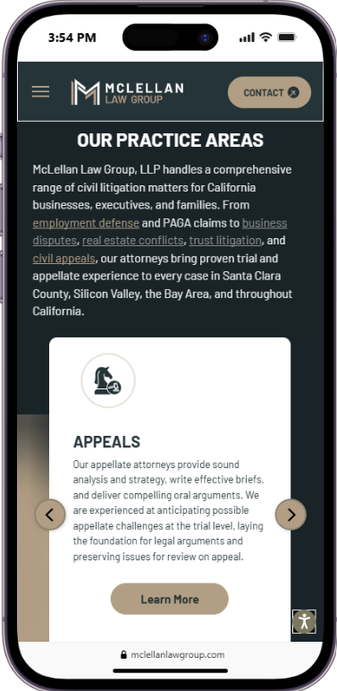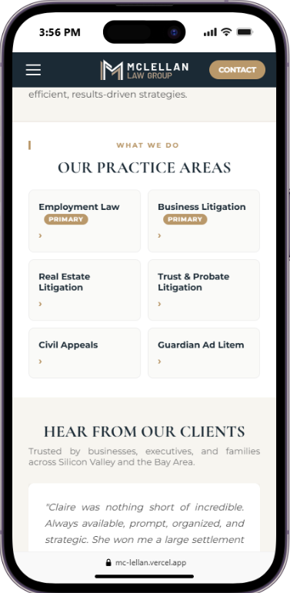

Before | After
The testimonials section displayed every review stacked vertically, one after another, with long unformatted blocks of text. On mobile, users had to scroll through several dense paragraphs before reaching any other content — making it unlikely anyone would actually read them. There were no practice area labels, no local keywords, and no visual hierarchy to guide the eye. | Each testimonial is short, punchy, and labeled with a practice area and location —Employment Law · Saratoga, Business Litigation · Saratoga reinforcing local SEO on every card. Reviews display in a swipeable carousel, so mobile users see one at a time without any extra scrolling. The format is scannable, credible, and built to convert.

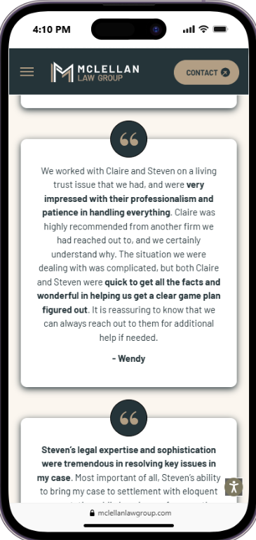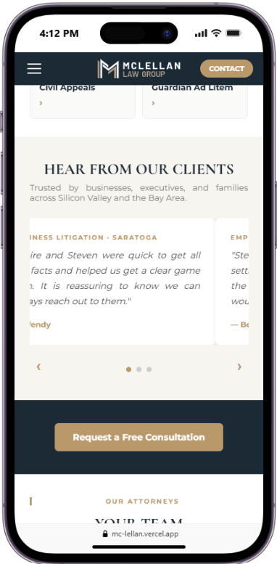

NAVIGATION
Logo: McLellan Law Group (SVG)
Links:
- Home
- Practice Areas (dropdown)
- Your Team
- Resources
- Contact Us
Dropdown — Practice Areas:
- Employment Law (featured)
- Business Litigation (featured)

- Appeals
- Real Estate Litigation
- Contract Disputes
- Financial Elder Abuse
- Trust & Probate Litigation
Right button: CONTACT

HERO (main section with background photo)
Background photo: team photo (Steven and Claire)
Photo treatment: warm filter + gold corner frame
H1: Employment & Business Litigation Attorneys in Saratoga, California
Subtitle (paragraph, not H2): Representing businesses, executives, and families across Silicon Valley & the Bay Area.
CTA Button: Request a Free Consultation

ABOUT SECTION
H2: Award-Winning California Civil Litigation Firm
Paragraph: Award-winning civil litigation firm serving Silicon Valley businesses, executives, and families with efficient, results-driven strategies.

PRACTICE AREAS SECTION
Label above: WHAT WE DO
H2: Our Practice Areas
2-column grid — 6 cards:
Card | Badge
Employment Law | Primary
Business Litigation | Primary
Real Estate Litigation | —
Trust & Probate Litigation | —
Civil Appeals | —
Guardian Ad Litem | —

TESTIMONIALS SECTION
H2: Hear From Our Clients
Subtitle: Trusted by businesses, executives, and families across Silicon Valley and the Bay Area.
Format: carousel (1 at a time on mobile, 3 side by side on desktop)
Review 1
- Label: Business Litigation · Saratoga
- Text: "Claire and Steven were quick to get all the facts and helped us get a clear game plan. It is reassuring to know we can always reach out to them."
- Author: — Wendy
Review 2
- Label: Employment Law · Saratoga
- Text: "Steven's ability to bring my case to settlement while keeping my focus on the bigger picture was most impressive. I would hire Steven again in a heartbeat."
- Author: — Benjamin
Review 3
- Label: Employment Law · Saratoga
- Text: "Claire was nothing short of incredible. Always available, prompt, organized, and strategic. She won me a large settlement and I would highly recommend her."
- Author: — Pete

MID-PAGE CTA
Centered button on dark navy background: Request a Free Consultation

OUR ATTORNEYS SECTION
NO CHANGES

FINAL CTA (top of footer)
Paragraph: Based in Saratoga and serving Silicon Valley, Santa Clara County, and the Bay Area.
Button: Request a Free Consultation
Button link: https://www.mclellanlawgroup.com/contact

FOOTER
Google Maps embed: 20665 4th St #202, Saratoga, CA 95070

Note: All technical SEO changes (meta tags, schema markup, geo tags) are detailed in the separate "Technical SEO Changes" document.

